**KEY MILESTONE: 2**

**DONATION MANAGEMENT SYSTEM**



**Spring 2025**

**Database Management Lab**

Submitted by:

**Nouman Khan (22PWCSE2107)**

**Tariq Jamil (22PWCSE2184)**

**Mahran Khan (22PWCSE2185)**

ClassSection **: A**

Submitted to:

**Engr. Summayea Salahuddin**

July 08, 2025

**Department of Computer Systems Engineering**

**University of Engineering and Technology, Peshawar**

**DONATION MANAGEMENT SYSYEM**

**Steps in Converting Conceptual Schema into Relational Schema:**

* Identified all entities from the ERD
* Listed all attributes for each entity based on the conceptual description and business rules.
* Assigned primary keys (PK) to uniquely identify each record in every table.
* Added foreign keys (FK) to represent relationships between entities.
* Mapped many-to-many relationships using a junction table.
* Ensured optional/mandatory relationships.

**Converting into 3NF:**

**Ensure First Normal Form (1NF):**

* All attributes must have atomic (indivisible) values.
* No multivalued or repeating group attributes.
* Each table must have a clear and unique primary key.

**Ensure Second Normal Form (2NF):**

* The schema must already be in 1NF.
* Remove partial dependencies — every non-key attribute must depend on the entire primary key (especially for composite keys).
* Move any attributes that depend only on part of a composite key to a separate table.

**Ensure Third Normal Form (3NF):**

* The schema must already be in 2NF.
* Remove transitive dependencies — no non-key attribute should depend on another non-key attribute.
* Move such attributes to separate tables and reference them using foreign keys.

**Relational Schema and in 3NF Form:**

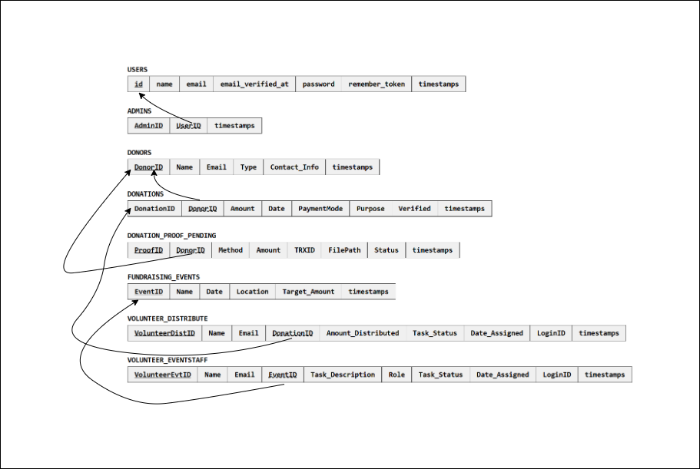

**References:**

* DBMS Lecture 2&3 Slides
* draw.io <https://www.diagrams.net>
* OpenAI *ChatGPT* <https://chat.openai.com>